Date:11/27/2022
COMP 3090-202 Fall 2022 Project

1) List all the doctors RICHARD MILLER is consulting.
Query:
SELECT D_NAME
FROM Doctors, Patients, p_assignment
WHERE Doctors.D_ID = p_assignment.D_ID
AND p_assignment.P_ID = Patients.P_ID
AND P_NAME = 'RICHARD MILLER';
Result:
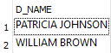
2) Find all the test results of cancer patients. (Note: There may be different type of cancer)
Query:
SELECT T_RESULT
FROM Tests, Patients
WHERE Tests.P_ID = Patients.P_ID
AND P_DISEASE LIKE '%Cancer%';
Result:
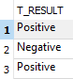
3) List all the instruments produced by a manufacturer whose name starts with "S".
Query:
SELECT I_NAME
FROM Instruments
WHERE I_MANUFACTURER LIKE 'S%';
Result:
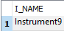

4) Find the most experienced doctor in the hospital.
Query:
SELECT D_NAME
FROM Doctors
WHERE D_YEARS_OF_EXPERIENCE = (SELECT MAX(D_YEARS_OF_EXPERIENCE) FROM Doctors)
Result:
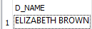
5) List all the patients of doctor JAMES SMITH who live in the same street and same city as him.
Query:
SELECT P_NAME
FROM Patients, Doctors, p_assignment
WHERE Doctors.D_ID = p_assignment.D_ID
AND p_assignment.P_ID = Patients.P_ID
AND D_NAME = 'JAMES SMITH'
AND Doctors.D_STREET = Patients.P_STREET
AND Doctors.D_CITY = Patients.P_CITY;
Result:
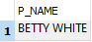
6) Find the nurses who assist at least two doctors. Display nurse name and the number of doctors he/she is assisting
Query:
SELECT N.N_NAME, count(D_ID) AS NUM_DOCTORS
FROM NURSES N, N_ASSISTS N_A
WHERE N.N_ID = N_A.N_ID
GROUP BY N.N_NAME
HAVING count(D_ID) >= 2;
Result:
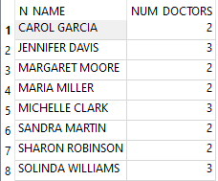
7) List the doctors and the number of nurses they have in the descending order of their number.
Query:
SELECT D_NAME, COUNT(N_ID) AS NUMBER_OF_NURSES
FROM DOCTORS D, N_ASSISTS N_A
WHERE D.D_ID = N_A.D_ID
Group by D.D_NAME
ORDER BY NUMBER_OF_NURSES DESC;
Result:
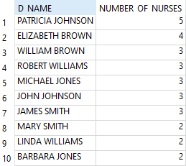
8) Find all the nurses who are not assigned to any doctors.
Query:
SELECT N_NAME
FROM Nurses
WHERE N_ID NOT IN (SELECT N_ID FROM n_assists);
Result:
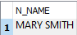
9) Increment years of experience of all the female doctors by 5.
Query:
UPDATE Doctors
SET D_YEARS_OF_EXPERIENCE = D_YEARS_OF_EXPERIENCE + 5
WHERE D_GENDER = 'f';
Result:
Snapshot of DOCTORS TABLE AFTER THE UPDATE IS BELOW
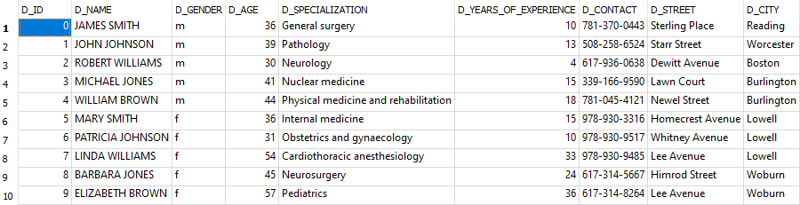
10) Delete all the tests whose result is negative
Query:
DELETE FROM Tests
WHERE T_RESULT = 'Negative';
Result:

Snapshot of TESTS TABLE AFTER THE UPDATE IS BELOW

